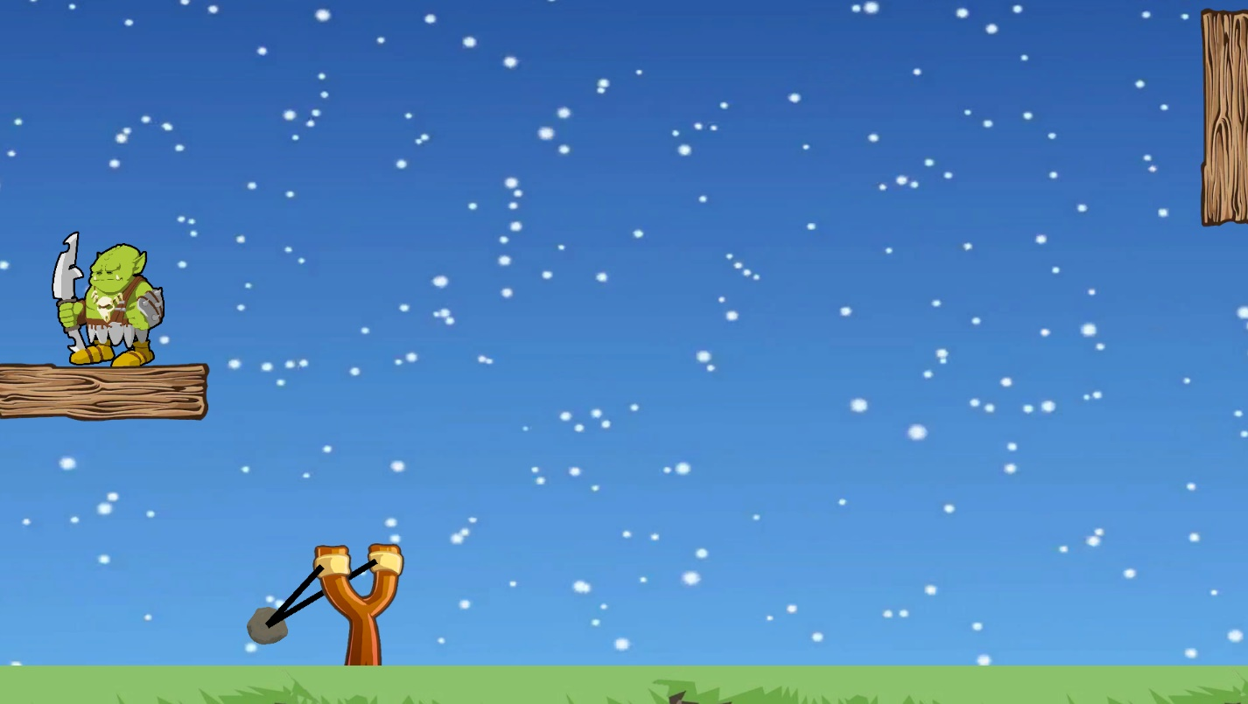

This game is a simple Angry Birds Knockoff that was for my Game Design course. It used in engine physics. The focus for this game personally was designing and implementing the level select menu. Download the .exe file to play this game. Press ‘R’ to reset the level if you get stuck. Sometimes the rock is a bit too bouncy!